DIS- Olmec Stone Celt Axe Middle Preclassic, ca.900-600 B.C

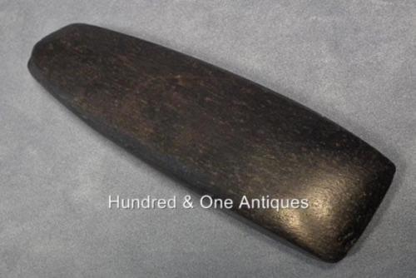

A superb quality Olmec Stone Celt Axe Middle Preclassic, ca.900-600 B.C made of dark black, polished hard stone (possibly Jade - chloromelanite) of tall expanding form, with slightly squared sides, and a sharpened edge.

From an old Canadian collection of Pre-Columbian Art

CONDITION: Showing its age and usage, some minor chips to the cutting edge, otherwise in good condition.

DIMENSIONS: Length: cm (in). Width in the widest point: cm (in).